LAB CYCLE 2

1. Change the color of all <p> elements to "red".

CODE

<html>

<head>

<style>

p {color: red;}

</style>

</head>

<body>

<p> arsenal is the best team in the world </p>

</body>

</html>

OUTPUT

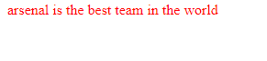

1. Create all <p> elements will be center-aligned, with a red text color.

CODE

<html>

<head>

<style>

h1 {color: blue}

p{

color: red;

text-align: center;

}

</style>

</head>

<body>

<h1> daily mail </h1>

<p> last night messi AND GRIEZMNN scored twice as barca put 4 against granada </p>

</body>

</html>

OUTPUT

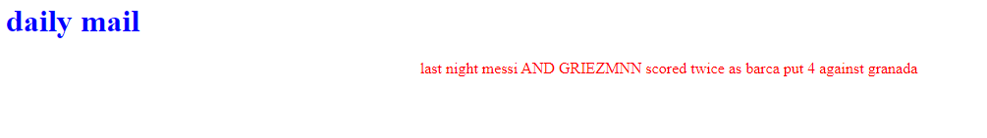

Set the background color for the page to "linen" and the background color for <h1> to "lightblue

CODE

<html>

<head>

<style>

body{background-color: linen}

h1{ color: lightblue}

</style>

</head>

<body>

<h1> twinkle twinkle little star how i wonder what you want.</h1>

</body>

</html>

OUTPUT

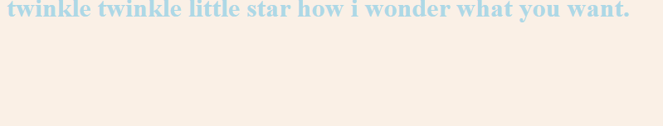

Set the font family for the page to "Courier New", and the font family for <h1> to "Verdana".

CODE

<!DOCTYPE html>

<html>

<head>

<style>

body {

font-family: courier new;

}

h1 {

font-family: verdana;

}

</style>

</head>

<body>

<h1>This is a heading</h1>

</body>

</html>

OUTPUT

